Immanuel Christian Secondary School – Lethbridge, AB

2018 South Zone Golf Championship

Date: Tuesday, September 18, 2018
Host: Immanuel Christian Secondary School
Place: Paradise Canyon Golf Resort
- 185 Canyon Blvd. West, Lethbridge, Alberta
Start: 9:30 am Shot-gun Start
Entry Fee: $70.00 per participant
Entry Deadline: Friday, September 14, 2018
Tournament Coordinators: Matthew Bekkering and Matt Barkway (RCGA)
Phone: 403-328-4783 (School) 403-381-GOLF (Course)
Email: matthew.bekkering@lethsd.ab.ca

2018 South Zone Golf Championships

Coaches/Supervisors Information

1. Date: Tuesday September 18, 2018
2. Alternate Date: Will be set within 24 hours of postponement.
3. Location: Paradise Canyon Golf Resort
4. Host: Immanuel Christian Secondary School - Lethbridge
5. Start Time: 9:30 am Shot-gun Start
6. Entry Deadline: Friday, September 14, 2018
7. Entry Fee: $70.00 per participant.
Maximum entry is 4 Boys and 4 Girls per school.
All cheques to be made payable to Immanuel Christian Secondary School, payable at the golf course prior to the start time.

8. Registration: 8:00 am to 9:00 am
9. Pull carts: Availability of pull carts will be limited. Any players wishing to use a pull cart must bring their own or be aware of the limitation.

10. Warm-up: Range balls will be provided. Warm-up green will be available for putting. Allow enough time to go to the driving range if desired.

11. Tournament Meeting: A meeting of all coaches, supervisors, and players will occur at 9:00 am. Tournament procedures, local rules, and any other necessary matters will be covered

12. Tee Markers: All boys will play from the White Tees.
All girls will play from the Yellow tees.

13. Coaches/Supervisors: Meet with your players immediately following the 9:00 organizational meeting and hand out their personal scorecards. Ensure that your players understand their assigned starting hole number, and that they are ready to leave for their hole 10 minutes prior to the Shot-gun Start. Some players will be shuttled by golf cart to their starting hole. During the round, volunteers will be on holes 18 and 9 to shuttle players to the next tee.

On the first tee players will:

- introduce themselves to their competitors and exchange scorecards (as discussed at the organization meeting). Coaches are responsible to ensure that their players understand the proper scoring procedure and how important it is for them to write down the correct score and write it legibly.

- be reminded of the importance of “Pace of Play” and their expectation to stay with the group ahead of them. Slow play will not be tolerated and penalty strokes may be issued. Coaches of players that are reported out of position will be asked to walk with the group until the group is back in position.

-announce the ball (with identifiable markings) that they are putting into play, to ensure that two players are not playing the exact same ball.

-be reminded to hit two balls if they are ever unsure about a ruling, and should ask for a proper ruling as soon as possible.

-be encouraged to hit a provisional ball if the first ball is in danger of being lost or out of bounds.

Once the round is completed:

The players will submit their signed scorecard to their coach who will confirm the score and check for legibility. The coach will read the scores to Marg Derbyshire for Results.

Coach Availability – all coaches must be available to assist their players at all times in case of emergency so we are asking them to remain at the Golf Course for the Tournament.

14. Meal: All players have included in their entry a meal ticket (included in your envelope package). Supervisors/coaches are invited to participate in the meal at a cost of $10.00 (payable at registration).

15. Grade 9 Players: In 1A schools only, grade 9 students can play on their school golf team and are eligible for Provincials if their team qualifies. Their score will not qualify for individual honors or the Individual qualifiers for Provincials.

16. Awards: The following awards will be presented for both boys and girls respectively:
1st Overall Individual Low Gross Champion (Gold Medal)
2nd Overall Individual Low Gross (Silver Medal)
3rd Overall Individual Low Gross (Bronze Medal)

1A/2A and 3A/4A School Team Championship Banners
Team Gold, Silver and Bronze medals.
The best 3 scores per hole will be calculated for the Team Score. Minimum of 3 players needed for a team.

17. Tournament Coordinator: Matthew Bekkering, Matt Barkway and Marg Derbyshire

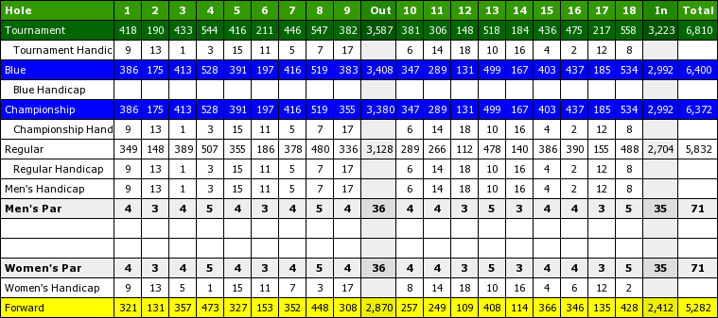

2018 South Golf Championships
Registration Form

School: _________________________________________

School Size: 1A 2A 3A 4A

Coach/Supervisor: __________________________________

Phone #: School: Cell:

Coach Lunch: Yes ___ No___

Intend to use driving range prior to golf: Yes ____ No _____

Boys
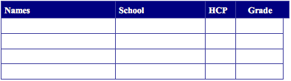

Girls
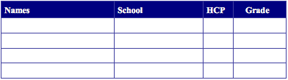

Players must also be registered on ExNet for ASAA eligibility. Deadline is September 12 (Please Check ASAA website for deadlines).

I certify that the above information is accurate and that each participant is eligible according to ASAA regulations.

Principal _______________________________________

**NOTE**: This form must be completed and returned to: matthew.bekkering@lethsd.ab.ca
NO LATER THAN FRIDAY, SEPTEMBER 14, 2018

